Feedback Session 2

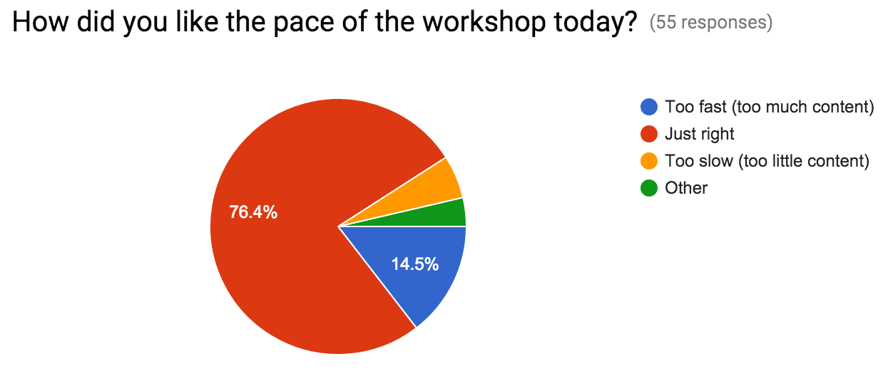

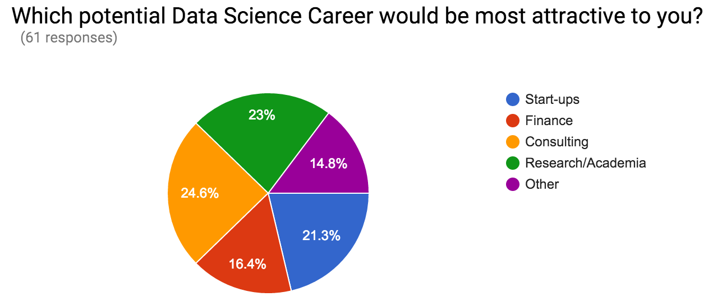

Why? (61 responses)

The start up business is growing continuously so it would be a good opportunity

Interested in applying for a PhD programme

Because it's where the fun's at

Useful software skills

Useful for analysing large amounts of data

Undecided and willing to try anything

useful to process large amounts of scientific data quickly

$

Engineering stuff

Not sure

Need a lot of experience on specific (and occasionnal) subject => only consulting can achieve that

You can tackle different problems from diverse fields

Neural networks & machine learning

R programming is just an interest.

Cool

I'd like to use it to do some data manipulation on lab work

I find it interesting to be able to use programming to analyse data

why not

Area I feel I am most likely to end up / would enjoy the most

know-how of how to handle large data sets is important in engineering

It has the most interesting data available for analysis Would consider consulting as well

Interesting

I'm just interested in knowing how to manipulate data and maybe do some research in a field that I like (Behavioral Economics etc..)

I believe it will come to use one day.

I feel like both consulting and Research/academia would benefit the most from being able to easily manipulate large amounts of data and present it into useful visualizations.

Technical aspect

I currently work in research data management in the central library, but have a background in biology (genomics), so am interested in applications of data science in tracking scholarly communications as well as learning more about applications in current research practice, particularly in the biological sciences.

Past experience

I'm considering a career in consulting.

Interested in doing data analytics on new data sets from sensors and slicks media.

Possibility to explore many different projects

I am interested in doing research in my field.

Would like to see an idea of mine progress

Innovative

Interested in using data to identify areas of opportunity to improve efficiency.

Seems very interesting

Not interested in it as a career, but it's a great tool in a number of different professions.

Engineering related.

Want to learn about Data Science just out of curiosity!

I think businesses can learn a lot from their data

Future career

I want to pursue a career in finance or consultancy industry

Consulting offers a wider range of projects data science can be applied to, and it yield practical results you can see in industry.

It would give me the opportunity to work on almost everything not on something specific.

Working culture

i like statistics

Sometimes, people do things not because of career reason.

Disrupt something using big data

I am interested in using data analytics to solve business case problems.

Based on previous experience

Previous experience in the field

I am a fan of efficiency, and so much data is produced that is only glanced over. Applying deeper analysis could aid significantly, especially in complex diseases.

Not interested in others

Consulting is where I feel that there are more applications for this

I am interested to look at the patterns and trends for Financial Data

I am considering a PhD in Economics

Can be potentially developed further.

Improve skills

Seems like it would have the most impact for good

Interest and career expectation